Question # 1

Void and value from the function.

#include <iostream>

#include <iomanip>

using namespace std;

void factorial();

void even_odd();

void prime();

int main()

{

int opt;

cout<<"For Factorial of the given number : Enter 1"<<endl;

cout<<"For checking of even or odd number : Enter 2"<<endl;

cout<<"For checking whether the given number is prime or not : Enter 3"<<endl;

cout<<"***********************************************************************"<<endl;

cout<<"Enter your option : ";

cin>>opt;

cout<<"***********************************************************************"<<endl;

if(opt==1)

{

factorial();

}

else if(opt==2)

{

even_odd();

}

else if(opt==3)

{

prime();

}

else

cout<<"Invalid Entery"<<endl;

return 0;

}

void factorial()

{

int i,n,f=1;

cout<<"Enter a number : ";

cin>>n;

for(i=1;i<=n;i++)

{

f=f*i;

}

cout<<"Factorial of the given number = "<<f<<endl;

}

void even_odd()

{

int n;

cout<<"Enter a number : ";

cin>>n;

if(n%2==0)

{

cout<<"Entered number is an even number "<<endl;

}

else cout<<"Entered number is an odd number "<<endl;

}

void prime()

{

int i,n;

cout<<"Enter a number : ";

cin>>n;

for(i=2;i<n;i++)

{

if(n%i==0)

{

cout<<"Given number is not a prime number "<<endl;

break;

}

}

if(i==n)

cout<<"Given number is a prime number "<<endl;

}

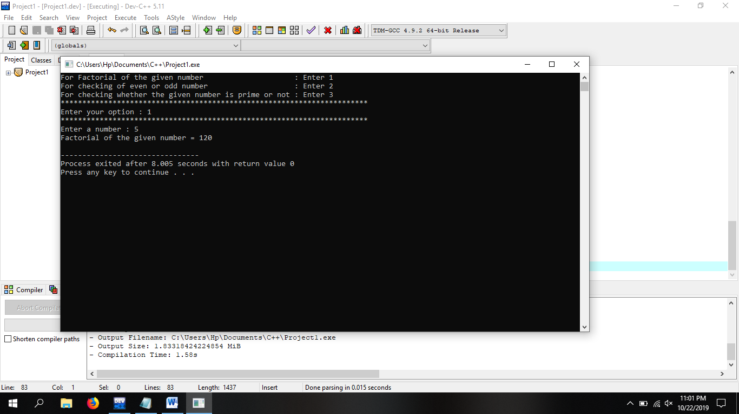

Question # 2

Void and value from the main function

#include <iostream>

#include <iomanip>

using namespace std;

void factorial(int);

void even_odd(int);

void prime(int);

int main()

{

int opt,n;

cout<<"For Factorial of the given number : Enter 1"<<endl;

cout<<"For checking of even or odd number : Enter 2"<<endl;

cout<<"For checking whether the given number is prime or not : Enter 3"<<endl;

cout<<"***********************************************************************"<<endl;

cout<<"Enter your option : ";

cin>>opt;

cout<<"***********************************************************************"<<endl;

cout<<"Enter a number : ";

cin>>n;

if(opt==1)

{

factorial(n);

}

else if(opt==2)

{

even_odd(n);

}

else if(opt==3)

{

prime(n);

}

else

cout<<"Invalid Entery"<<endl;

return 0;

}

void factorial(int x)

{

int i,f=1;

for(i=1;i<=x;i++)

{

f=f*i;

}

cout<<"Factorial of the given number = "<<f<<endl;

}

void even_odd(int x)

{

if(x%2==0)

{

cout<<"Entered number is an even number "<<endl;

}

else cout<<"Entered number is an odd number "<<endl;

}

void prime(int x)

{

int i;

for(i=2;i<x;i++)

{

if(x%i==0)

{

cout<<"Given number is not a prime number "<<endl;

break;

}

}

if(i==x)

cout<<"Given number is a prime number "<<endl;

}

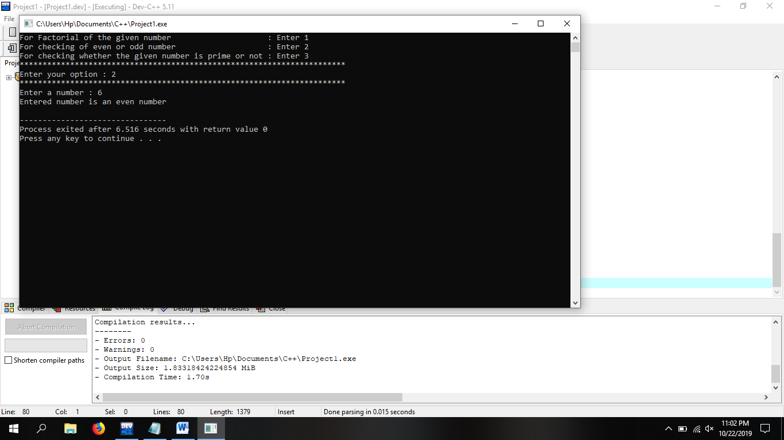

Question # 3

With return function

#include <iostream>

#include <iomanip>

using namespace std;

int factorial(int);

int even_odd(int);

int prime(int);

int main()

{

int opt,n;

cout<<"For Factorial of the given number : Enter 1"<<endl;

cout<<"For checking of even or odd number : Enter 2"<<endl;

cout<<"For checking whether the given number is prime or not : Enter 3"<<endl;

cout<<"***********************************************************************"<<endl;

cout<<"Enter your option : ";

cin>>opt;

cout<<"***********************************************************************"<<endl;

cout<<"Enter a number : ";

cin>>n;

if(opt==1)

{

int abc=factorial(n);

cout<<"Factorial of given number = "<<abc;

}

else if(opt==2)

{

int abc=even_odd(n);

if(abc==true)

cout<<"EVEN NUMBER";

else

cout<<"ODD NUMBER";

}

else if(opt==3)

{

int abc=prime(n);

if(abc==true)

cout<<"It is a prime number";

}

else

cout<<"Invalid Entery"<<endl;

return 0;

}

int factorial(int x)

{

int i,f=1;

for(i=1;i<=x;i++)

{

f=f*i;

}

return f;

}

int even_odd(int x)

{

if(x%2==0)

{

return true;

}

}

int prime(int x)

{

int i;

for(i=2;i<x;i++)

{

if(x%i==0)

{

cout<<"Given number is not a prime number "<<endl;

break;

}

}

if(i==x)

return true;

}

